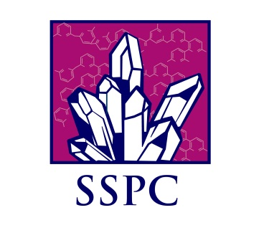

**2 PhD STUDENT POSITIONS:**

**Crystal Nucleation of Pharmaceutical Compounds**

|  |
| --- |
| **Expected background:** BSc/MSc in chemistry or materials science, or BEng/MEng in chemical engineering |
| These positions are part of a five year, larger, high profile and challenging research project financed by the Science Foundation Ireland (SFI). The project includes two postdoctoral fellows and three PhD students, and will investigate crystal nucleation of complex organic molecules in solution, for the purpose of advancing the control and efficiency of crystallization of modern and future pharmaceutical compounds. The PhD projects are focused on various experiments on crystal nucleation of pharmaceutical compounds. The candidates are expected to have experience of chemical/chemical engineering laboratory work, and must have an interest for careful and qualified experimentation. The work may include evaluation of experiments by mathematical modelling, and hence at least one of the candidates is expected to have a suitable background and interest for this. The work may also include participation in the development of experiments using synchrotron radiation Small Angle X-ray Scattering at a suitable Large Scale Facility |
| Primary nucleation denotes the formation of a new particle in the solution, having a size sufficient for it to be thermodynamically stable at the prevailing conditions. The development of the fundamental understanding of primary nucleation has been very slow, which is due the complexity. Primary nucleation occurs in the nano-size range, has a very strong non-linear dependence on the supersaturation, and has a significant stochastic component. Nucleation is one of the key mechanisms of crystallization processes, which are of significant importance to our society in industrial production of various materials; in the formation of shells and bone structures in nature; and for some diseases. In the industrial production of pharmaceutical compounds, crystallization is repeatedly used to separate and purify intermediates, and is of major importance for the purification of the final product. Crystal nucleation has a governing influence on the product properties as well as on the robustness of a crystallization process. At the same time, nucleation is the mechanism of crystallization that is the least understood which leads to significant problems in the design, operation and control of industrial processes.  The project will have full access to the experimental facilities of the Materials and Surface Science Institute (MSSI) at the University of Limerick (UL). The project will be very much linked to two other post graduate students already working in the area and to the Solid State Pharmaceuticals Cluster (SSPC) in which there are additional 5 PhD students, one postdoc and two additional senior researchers at UL, working on various aspects of crystallization of pharmaceuticals.  For further details please contact professor Åke Rasmuson: [**ake.rasmuson@ul.ie**](mailto:ake.rasmuson@ul.ie)  and visit the web page:  <http://www2.ul.ie/web/WWW/Faculties/Science_&_Engineering/Research/Research_Institutes/MSSI> |