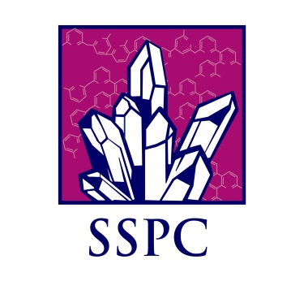

PhD STUDENT POSITION:
TUNED PHARMACEUTICAL CRYSTALLISATION

Expected Background: BSc/MSc in Chemistry, Biochemistry or Materials Science or BEng/MEng in Chemical Engineering

The position is part of a larger, high profile, challenging research project financed by Science Foundation Ireland. Specifically this project involves investigating a wide range of experimental parameters so that the particle size, shape and polymorphic form can be tuned at will over a wide range of possible outcomes. The project involves working with two postdoctoral fellows and a number of other postgraduate students who will work collectively towards advancing the control and efficiency of crystallisation of modern and future pharmaceutical compounds. The successful candidate is expected to have experience of chemical/chemical engineering laboratory work, and must have devotion for careful and qualified experimentation.
Current state of the art in crystallisation control is to work towards getting reproducible results, especially when working with large volumes. The question of being able to tune the size, shape and polymorph of a specific pharmaceutical powder has rarely if ever been achieved. This project will focus on how this might be achieved. The approach will be to take a single pharmaceutical compound and explore the experimental conditions which lead to a variety of sizes, shapes and polymorphs. Factors to be investigated initially will include, solvent choice, including suitable mixtures of solvents, the role of impurities, additives, seeding, supersaturation and temperature.
The project will be linked to the Solid State Pharmaceutical Cluster. For further details please contact Professor Kieran Hodnett or Dr Denise Croker denise.croker@ul.ie
Http://www2.ul.ie/web/WWW/Faculties/Science_&_Engineering/Research/Research_Institutes/MSSI/Research_Themes/SSPC

